Bank Management System

Home page

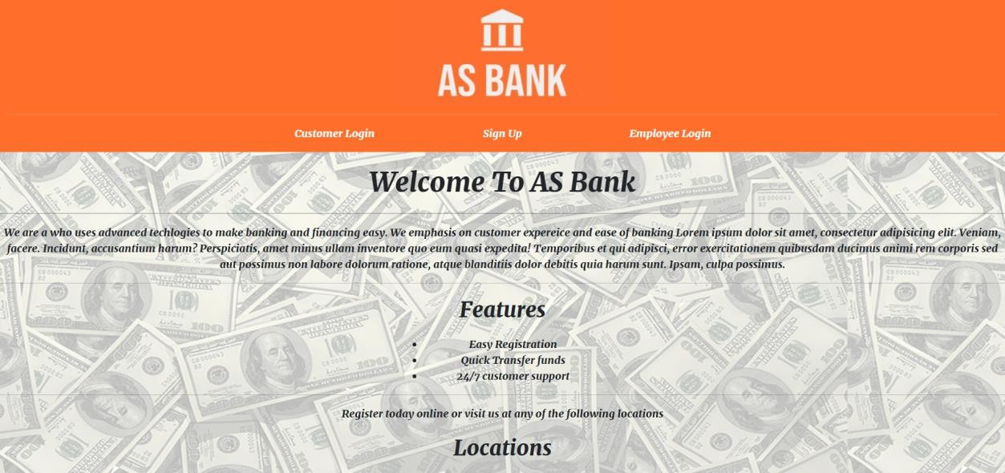

User sign up

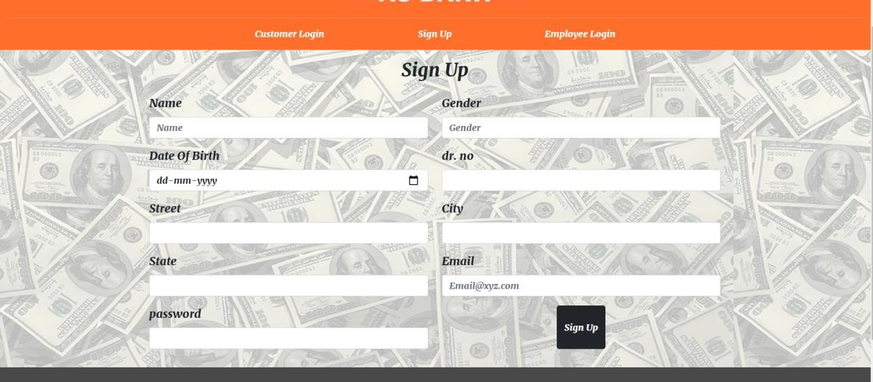

User login

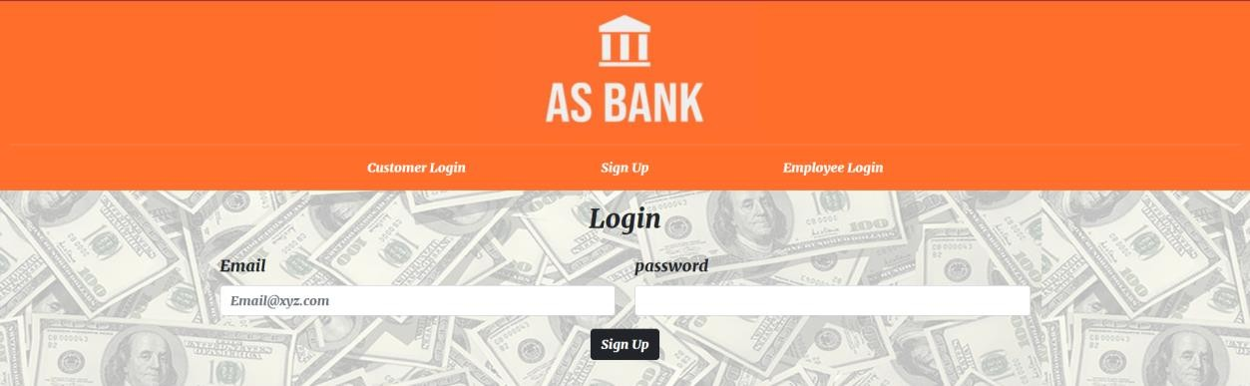

User account details

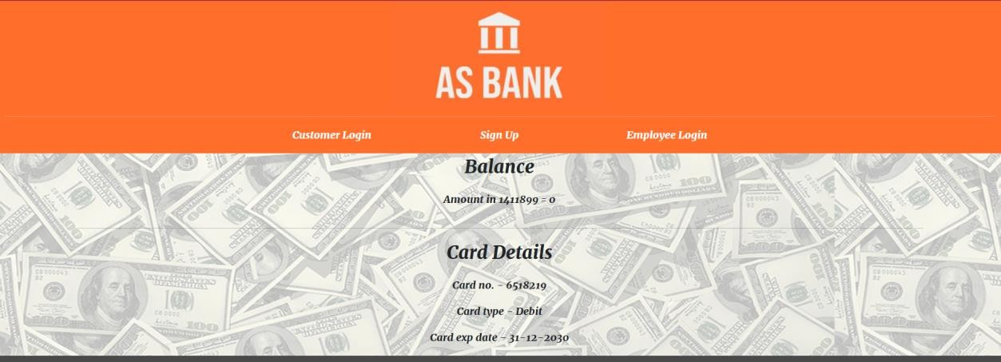

Authentication details

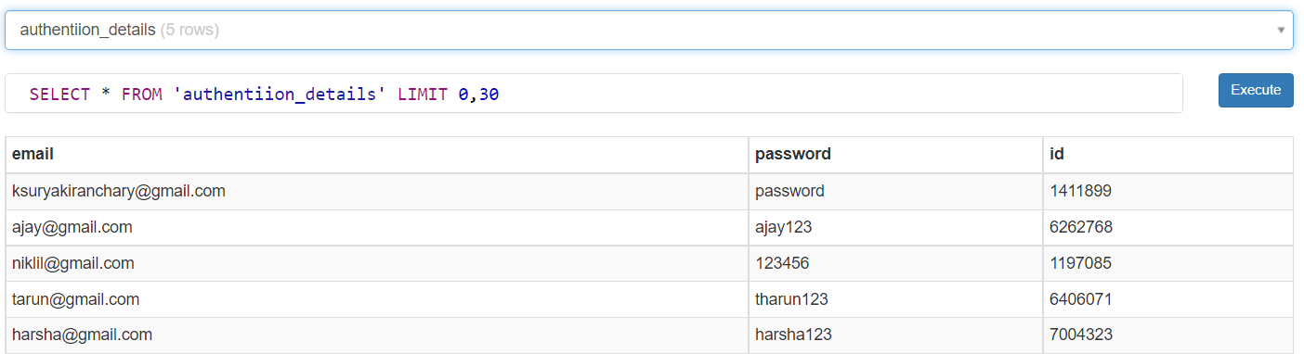

Account details table

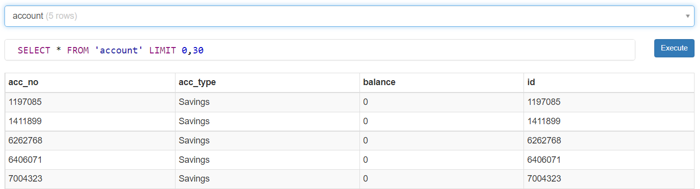

Customer details table

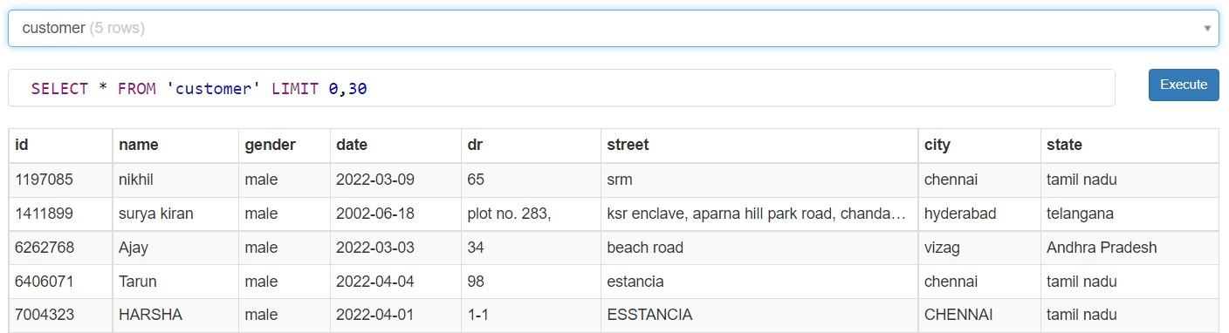

Card details table

